CAST BIOGRAPHY
The cast of The History Boys is full of old and new faces at the Forum Studio Theatre.
We welcome newcomers Vanda Hargen and Nick Sample, both experienced performers and both making their first appearance for Tip Top. Andy Jordan and Simon Phillips are very familiar to our audiences and were last on stage together in ‘The Wizard of Oz’ at Clwyd Theatr Cymru where Andy played the Scarecrow and Simon the Tin Man.
All of the boys are drama students of one sort or another. Matthew Newman, Joe Roberts and Alex Hunt are all studying BTEC in Performing Arts at Yale College, Wrexham.

James Ralph is studying ‘A’ level Theatre Studies at Bishops High School and Josh Horrocks ‘A’ level Drama at Christleton High School. Matthew O’Connor is also following an ’ A’level course at John Summers High School.

Phillip Laing is a member of National Youth Theatre and Andrew Heath has a BTEC in Peforming Arts. All are already working towards full time careers as performers.

Ruth Evans has produced and directed a number of shows for Tip Top Productions, the most recent being ‘Art’ in 2008.
The History Boys
Cast:
Atkins - Andrew Heath
Crowther - Matthew O'Connor
Dakin - Josh Horrocks
Lockwood - Alex Hunt
Posner - Joe Roberts
Rudge - James Ralph
Scripps - Phillip Laing
Timms - Matthew Newman
Hector - Nick Sample
Irwin - Simon Phillips
Headmaster - Andy Jordan
Mrs Lintott - Vanda Hargen
Fiona – Julie Blagrove
Production Team:
Director - Ruth Evans
DSM- Pippa Redmayne
Choreographer- Andrew Heath
Filming - Lucy Lincoln, Joe Kennett
Props - Kirsty Stubbert
ASM - Zoey Boyd, Charlotte Rutherford
Costume – Julie Blagrove
Lighting – Ian Jones, Mark Shenton
Sound – Gary Roberts
Publicity – Jean Thomason, Pam Bauer
Musical Director – Simon Phillips

With thanks to Richard Sisson (original music
arrangement for the 2004 NT production),
and National Theatre Archive

The Play

The mid eighties, at a boys’ state grammar school in the North of England. Eight boys who have completed their ‘A’ levels are returning to school to study for their Oxbridge entrance exams. Throughout the course of the term they are subjected to the petty quarrelling and staffroom politics of their teachers. Loyalties are stretched, and challenged.

During all of this, the main concern of the boys is getting out, starting university and starting life. Those who are on the edge of life are confronted with those who are
jaded and remorseful, and to whom life has not been kind.

The history of The History Boys

This play had its premiere in the National Lyttelton Theatre on the 18th May 2004.

The second production opened in the Lyttelton Theatre on the 23rd September 2005, before going on UK tour.

The original cast took the production on tour to Hong Kong, Australia and New Zealand before arriving at the Broadhurst Theatre on Broadway on 23rd April 2006.

In 2006 and again in 2007 the production toured the UK before runs in London’s West End.

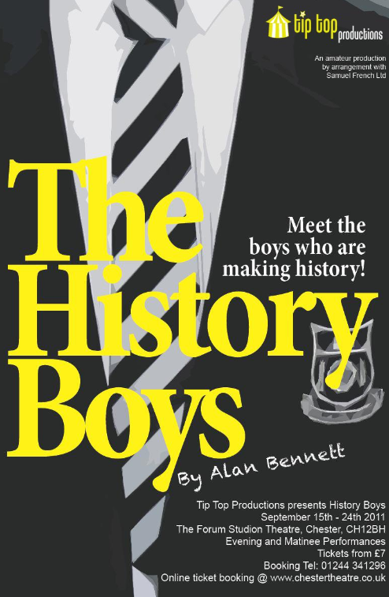

DIRECTOR’S NOTES

What a lovely time we have had creating this production! In spite of various disruptions beyond our control the company have taken the meaning of “ensemble piece” to a whole new level.

Rehearsals were a democratic affair. From all of us pooling our ideas and interpretations of the often ‘highbrow’ text to Vanda coaching the boys in their French and James passing on his ‘A’ level history studies to mention just a couple of examples. Everyone has played a huge part in making the show a success.

It seems to me very fitting that the warmth and enjoyment we have shared is well matched by the warmth and intimacy of Bennett’s text. Perhaps there is more than a coincidence there.

WITH SPECIAL THANKS

Michael Beigel for his invaluable support and assistance during the early rehearsals.
Queens Park High School, Chester for furniture and the use of the school as the filming location. Llangollen Motor Museum for the loan of crash helmets. Ableworld for the loan of the wheelchair. Matt Yeoman, Andrew Roberts and Lee Hassett for production support. Steve Davies and the Tip Top front of house team.

Also at the Forum Studio Theatre

Sunny Rhyl
Saturday 1st October, 7.30pm

In The Mood
Sunday 2nd October, 7:30pm

Humble Boy
5th – 7th October, 7:30pm

Born This Way
8th & 15th October, 7:30pm

An Inspector Calls
Friday 14th October, 7:30pm

Of Mice and Men
2nd – 5th November

Showtune
The music of Jerry Herman
10th – 19th November

Jack & The Beanstalk
Traditional family pantomime
10th – 30th December

01244 341296 WWW.CHESTERTHEATRE.CO.UK

