Ensemble:
Laura Roberts, Julie Blagrove, Grace Inskip, Sian Williamson, Fiona MacSween,
Caroline Dutton & Natalie Brett.

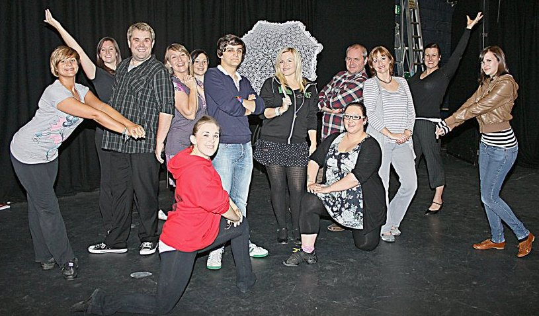

Cast:
Maureen Tolefree, Sandra Jones, Sophie Bill
Rob Tolefree, Rob Stevens & Joe Roberts

Act I - Musical Numbers

It's Today!........................................................................Mame
Big Time............................................................Mack & Mabel
We Need a Little Christmas.........................................Mame
Put On Your Sunday Clothes...........................Hello, Dolly!
Little More Mascara................................La Cage aux Folles
The Man In The Moon..................................................Mame
I Am What I Am......................................La Cage aux Folles
Song On The Sand – Prelude.................La Cage aux Folles
I Won't Send Roses.........................................Mack & Mabel
Ribbons Down My Back....................................Hello, Dolly!
Dancing...............................................................Hello, Dolly!
It Takes A Woman.............................................Hello, Dolly!
Wherever He Ain't...........................................Mack & Mabel
Hundreds Of Girls ..........................................Mack & Mabel
So Long Dearie....................................................Hello, Dolly!
It Takes A Woman – Reprise.............................Hello, Dolly!
And I Was Beautiful.............................................Dear World
Kiss Her Now........................................................Dear World
And I Was Beautiful / Kiss Her Now.................Dear World
Time Heals Everything...................................Mack & Mabel
Before The Parade Passes By.............................Hello, Dolly!
One Person.............................................................Dear World
Open A New Window...................................................Mame
Counterpoint March.....Hello, Dolly! Dear World & Mame
Before The Parade Passes By – Reprise...........Hello, Dolly!

Act II – Musical Numbers

Entr’acte..................................................................Hello, Dolly!
Movies Were Movies.........................................Mack & Mabel
Look What Happened To Mabel.....................Mack & Mabel
That's How Young I Feel.................................................Mame
Look What Happened to Mabel – Reprise.....Mack & Mabel
My Best Girl.......................................................................Mame
Nelson............A Day in Hollywood/A Night in the Ukraine
Just Go To The Movies........A Day in Hollywood/A Night...
It Only Takes A Moment.....................................Hello, Dolly!
What Do I Do Now?.........................................................Mame
Tap Your Troubles Away.................................Mack & Mabel
Bosom Buddies.................................................................Mame
I Don't Want To Know...........................................Dear World
I Don't Want To Know – Reprise..........................Dear World
Song On The Sand......................................La Cage aux Folles
Shalom..............................................................Milk and Honey
I'll Be Here Tomorrow....................................The Grand Tour
If He Walked Into My Life..............................................Mame
I Promise You A Happy Ending......................Mack & Mabel
Mame..................................................................................Mame
The Best of Times........................................La Cage aux Folles
It's Today! – Reprise.........................................................Mame
Hello, Dolly! – Encore..........................................Hello, Dolly!
It's Today! – Playout.........................................................Mame

Showtune is an internationally popular Off-Broadway musical revue celebrating the words and music of Broadway composer Jerry Herman

Showtune Band

Keyboard 1........................................Tim Jones
Keyboard 2......................................Cliff Lloyd
Keyboard 3............................Michael Cannon

Production Team
Director / Choreographer.......................Rob Stevens
Musical Director...........................................Tim Jones
Assistant Director.................................Laura Roberts
DSM..................................................Lizzie O’Sullivan ASM.........................................................Vicki Hussey Lighting.................................................Mark Shenton
Sound....................................................Gareth Roberts Props......................................................Sheila Roberts
Wardrobe / Set........................................Allan Forrest

Thanks to Steve Davies and the Tip Top front of house team, Fiona MacSween & Ian Jones.

Would you like to play a bigger part in Tip Top’s Productions and help keep theatre alive in Chester….?

Visit our website at www.chestertheatre.co.uk and register for our regular newsletter, read about forthcoming audition opportunities, and learn how to get involved on stage, back stage and front of house.
Showtune
Please Note:
This performance contains Strobe Lighting.

7th – 16th May 2009
www.tiptopproductions.co.uk

Also at the Forum Studio Theatre

Tip Top Productions presents

Jack and the Beanstalk
December 10th - 30th

Fawlty Towers
February 23rd – March 3rd 2012

Stags and Hens
March 22nd - 31st 2012

Who's Afraid of Virginia Woolf?
April 19th - 21st 2012

Funny Peculiar
May 10th - 19th 2012

01244 341296 WWW.CHESTERTHEATRE.CO.UK

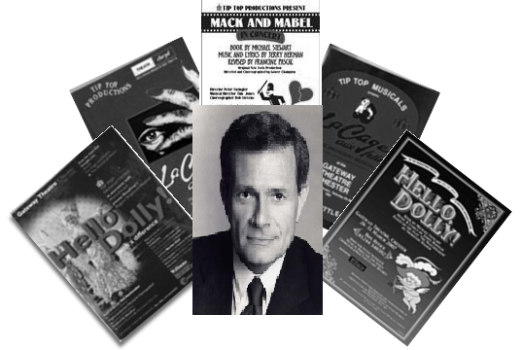
There is never an evening when, somewhere in the world, the music and lyrics of Jerry Herman are not being sung by a lady in a red head-dress or a lady with a bugle, or a middle-aged man in a wig and a boa.

Hello, Dolly!, Mame, and La Cage are home to some of the most popular, most-often performed and most successful musical heroines of all time, and have given Jerry Herman the distinction of being one of only two composers/lyricists to have three musicals run more than 1500 consecutive performances on Broadway (the other being Stephen Schwartz).

His Broadway shows include From A to Z (1960), Milk and Honey (1961), Hello, Dolly! (1964), Mame (1966), Dear World (1969), Mack & Mabel (1974), The Grand Tour (1979), A Day in Hollywood/A Night in the Ukraine (1980) La Cage aux Folles (1983), Jerry’s Girls (1985). Added to that is "Mrs. Santa Claus" (1996), a CBS TV special starring Angela Lansbury and also two of Jerry's classic songs are the emotional highlights of the hit Disney-Pixar film WALL-E.

His string of awards and honors includes multiple Tonys, Grammys, Drama Desk Awards, the Johnny Mercer Award, the Richard Rodgers Award, the Oscar Hammerstein Award, the Frederick Lowe Award, the Songwriters Hall of Fame and the Theatre Hall of Fame

Tip Top Productions aims to promote music, drama and theatre for all. Participation is open to anyone interested either on stage, backstage or front of house. To find out more about Tip Top, our future programme, or to be placed on our mailing list, please contact Peter Roberts at 20 Rhodfa Annwyl, Rhuddlan, LL18 2SQ or email: info@tiptoproductions.co.uk

www.tiptopproductions.co.uk

Tip Top Productions would like to thank the management and staff of The Stiwt for the help and support

