Writer
Paul Kelly

Paul lives in Chester and is an English Literature Graduate.
After professional readings at the Liverpool Everyman (2005) and the Sale Arts Centre (2007) with the plays ‘Hats’ and ‘The Ring’ respectively, Paul’s award winning play ‘The Burnage Boffin’ was performed at the URBIS in Manchester (2007). This led to his next play, ‘Fake’, playing in front of sell out audiences at the 2007 Chester Literature Festival.
After being mentored for 9 months by Charlotte Keatley (My Mother Said I never Should) a professional reading of the play ‘Brag’ was performed at the Oldham Coliseum. Paul then produced and wrote, in conjunction with a selection of North-West Playwrights, a show called ‘One Voice’ for the 2008 Chester Literature Festival.
Paul teaches Creative Writing on a part-time basis.


Cast

Margaret Gallagher
Christine dukes

Christine Dukes has been a regular performer and director in North Wales and Chester for so many years that she would like to forget the exact number! Suffice to say that she is finally playing her age! Having begun her theatrical career at the age of 3, she has since performed with companies such as CMMS, the Twenty Club, Grove Park Little Theatre and of course Tip Top Productions.
She has directed almost 50 productions in the past 34 years including ‘Misery’ for Tip Top, ‘Relative Values’ for the Twenty Club and several Welsh premieres including ‘The Best Little Whorehouse in Texas’. In early 2011 she will direct ‘Shirley Valentine’ for Tip Top and is looking forward to working on this challenging play, the challenge being in discovering a fresh look on a much-loved script and hopes that the actress she casts will play a major part in the exploration as well as the execution of the role

Cast

Anita Buckingham
Claire O’Neill

Claire began acting at fourteen when she went to the Everyman Youth Theatre. After leaving school she began working as a lead vocalist and illusionist’s assistant at holiday camps in the south west of England. She settled in the south west but decided to apply to drama schools. Claire was accepted into LIPA and moved back to Liverpool to study for a post graduate degree in acting. Since graduating she has worked with Lodestar Theatre Company on a street theatre production called “The Sonnet Walks” as part of The Liverpool Shakespeare Festival. Claire has worked on musical productions at the Unity Theatre and as a freelance actor for Samantha Giblins Little Actors Theatre Company. Her most recent performance was with Sense of Sound at the Dada festival last December.

Cast

Clare Toms
Tammy Foley

Tammy is a professional actress and drama facilitator based in Manchester. She has previous experience is TIE and has recently completed a National Tour. She is a highly experienced facilitator and has previously worked at the Lowry, The Octagon Theatre, Bolton and also with Altru Drama, Liverpool and Open Minds Theatre, Rotherham to name a few.
Tammy is very excited to be making her debut in Chester with Tip Top Productions. She would like to thank Jack, her beautiful son, Chris, Katherine and anyone else she could rope in for helping her to learn her lines!

Production Team

Director Steve Davies
DSM Rob Stevens
ASM Peter Brownbill-Hughes
Props Sandra Rogers
with Annette Clemence
Lighting Ian Jones

Additional Thanks

The production team are grateful to the actors who gave up their time in the early days of writing to read and improvise initial drafts of the play. This time of early character development was an invaluable tool towards developing the production that you are seeing tonight.



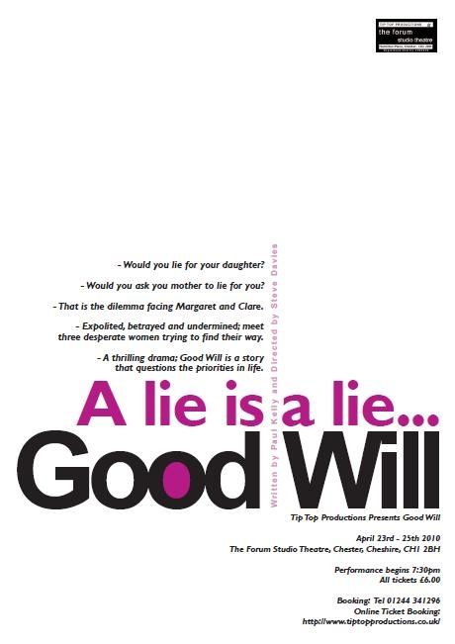

www.tiptopproductions.co.uk

7th – 16th May 2009
www.tiptopproductions.co.uk

Context
Good Will is set in the Adult Education department of the Local Council; where Government targets rule how much funding the council receives annually. The majority of Adult Education tutors work part-time and consequently a transient workforce is inevitable.
Notes
When Steve directed ‘Good Will’ - the 10 minute monologue for the ‘One Voice’ show 18 Months ago, I knew we were onto something.
We’d discussed developing the story into a full length play informally, but when a slot came available on the Tip Top programme it became a reality very quickly.
Over the past six months more than 10 actors have read for us while we listened and tried to find a structure and a voice for the play; from a 1st draft to the one the actors are working with - there will undoubtedly be more.
Both Steve and I have played every character and questioned every line. He’d then send me away to re-draft and some time later I’d come back with a new play and we’d try again.
Tonight is the culmination of this process; however I don’t yet see the play as complete. I hope that we can build from the first run at The Forum, re-draft and refine and take the play on tour.
Every actor that read has been gracious, even if at times there were areas for development and I must thank them for that.
I also want to thank the Tip Top team who have been professional and very supportive of me and this project.

Paul

Tip Top Productions
present

Up ‘n’ Under
by John Godber
at The Forum Studio Theatre
8th – 15th May 2010

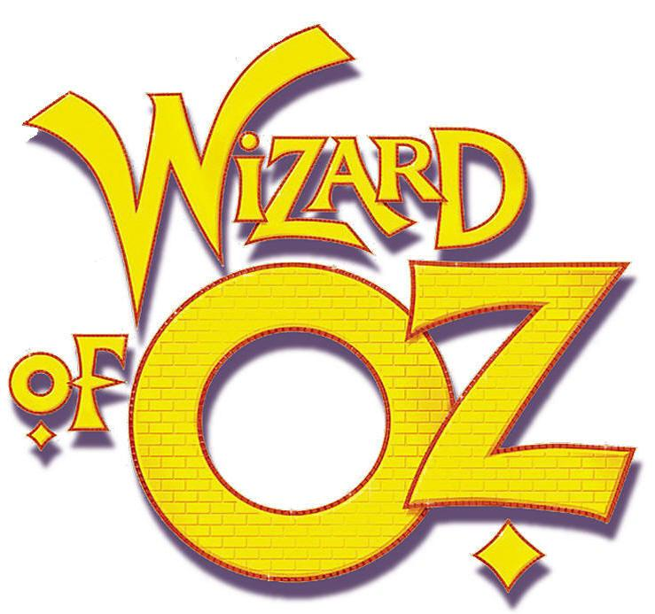

15th – 19th June 2010

Tip Top Productions are back at
Clwyd Theatr Cymru

Director - Steve Davies
Musical Director – Tim Jones
Choreographer – Rob Stevens

Box Office 0845 330 3565

or book online

www.clwyd-theatr-cymru.co.uk

Tip Top Productions aims to promote music, drama and theatre for all. Participation is open to anyone interested either on stage, backstage or front of house. To find out more about Tip Top, our future programme, or to be placed on our mailing list, please contact Peter Roberts at 20 Rhodfa Annwyl, Rhuddlan, LL18 2SQ or email: info@tiptoproductions.co.uk

www.tiptopproductions.co.uk

Tip Top Productions would like to thank the management and staff of The Stiwt for the help and support

23rd - 25th April 2010

