Tip Top Productions
Tip Top Productions
Funny Peculiar
By Mike Stott
Funny Peculiar
By Mike Stott

First performance of this production
10th May 2012
The play is set in a village somewhere in the Pennines

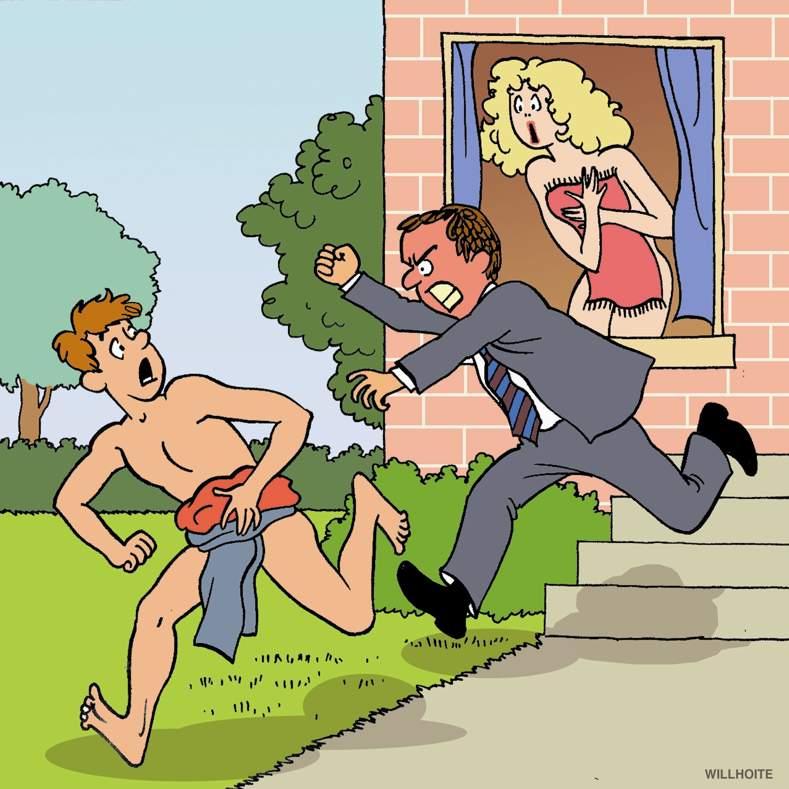
Cast

Trevor Tinsley
Paul Quinn

Irene Tinsley
Julie Blagrove

Rev. Thwaite
Eric Jones

Sergeant Harry Asquith
Steve Lancashire

Mrs Baldry
Fiona Grant

Stanley Baldry
Jamie Ablett

Shirley Smith
Rachel Sumner

Eric Smith
Richard Taylor

Desmond Ainsley
Simon Phillips

Shane Pritchard
Eric Jones

PRODUCTION TEAM

Assistant Director/Sound
Brian Fray

ASM
Oliver Price

Set Design
Andrew Roberts

Lighting
Ian Jones

Props
Muriel Jennings
Sheila Roberts

Wardrobe
Mel Regan
theatrecostumehire.com

Director
Peter Swingler OBE

Facebook.com/tiptoptheatre

Twitter.com/tiptoptheatre

YouTube.com/tiptoptheatre

First performance of this production
10th May 2012
The play is set in a village somewhere in the Pennines

Cast

Trevor Tinsley
Paul Quinn

Irene Tinsley
Julie Blagrove

Rev. Thwaite
Eric Jones

Sergeant Harry Asquith
Steve Lancashire

Mrs Baldry
Fiona Grant

Stanley Baldry
Jamie Ablett

Shirley Smith
Rachel Sumner

Eric Smith
Richard Taylor

Desmond Ainsley
Simon Phillips

Shane Pritchard
Eric Jones

PRODUCTION TEAM

Assistant Director/Sound
Brian Fray

ASM
Oliver Price

Set Design
Andrew Roberts

Lighting
Ian Jones

Props
Muriel Jennings
Sheila Roberts

Wardrobe
Mel Regan
theatrecostumehire.com

Director
Peter Swingler OBE

Facebook.com/tiptoptheatre

Twitter.com/tiptoptheatre

YouTube.com/tiptoptheatre

First performance of this production
10th May 2012

