Chris Jones – Ralph

Chris has had a tremendous amount of fun appearing in Bouncers, and as the only member of the cast who has not done the show before has felt very warmly welcomed. He has been a member of Grove Park Theatre in Wrexham for sixteen years, where he has performed a diverse number of roles from an American hostage in Someone Who’ll Watch Over Me to Seymour in Little Shop of Horrors via a number of pantomime comic performances in between, the last seven of which he has written. He has directed Thick as a Brick and 84, Charing Cross Road and assisted on a number of other occasions. Other notable shows he’s been in over that time include Bugsy Malone, The Madness of George III, Taking Steps, The Rivals, Salt of the Earth, Mystery at Greenfingers, Our Day Out and The Flint Street Nativity. He is currently Grove Park Theatre’s technical director and can often be found doing lighting, sound or stage management things. In New Year he will once again be working with Rob as he takes up the role of Assistant Director on a production of Men of the World. He can also be found doing lighting design for a number of other big and small theatre groups in North Wales and the North West. It has been both a challenge and a pleasure to be involved in this production and I must thank my fellow bouncers and the production team for making it such an enjoyable experience.

Stuart Evans – Les

Stuart graduated LIPA in 2004 and since then has gone on to work in television, film and stage. He has worked on many Tip Top Productions, including Something Funny Happened on the way to the Forum, Breezeblock Park, Flint Street Nativity and Sunny Rhyl, which is going on a North West tour in October.

Bouncers

Cast

Lucky Eric
Mike Kelsall
Judd
Andy Jordan
Ralph
Chris Jones
Les
Stuart Evans

Production Team

Director
Rob Stevens
Asst Director
Julie Blagrove
Stage Manager
Lizzie O’Sullivan
Lighting
Ian Jones
Sound
Gary Roberts
Poster Design
Paul Kelly

With thanks to the Tip Top Front of House Team.

Mike Kelsall – Lucky Eric

Mike is delighted to be appearing in only his second play, his first one being… erm, Bouncers.!
Since performing the role of Lucky Eric with Tip Top some 5 years ago, he has been eagerly awaiting the opportunity to revise the role of the elder statesman of the quartet of Doormen. As such, to help ensure he was ideally cast he has put on 2 stone in weight and gone almost bald! Now that’s commitment!!
Other appearances include: Julian Marsh in 42nd Street, Fred Graham/Petruccio in Kiss Me Kate, Bill Sikes in Oliver, Mack Sennett in Mack & Mabel, Jigger Craigin in Carousel, Judas/John the Baptist in Godspell, Harold in The Full Monty, Wild Bill Hickock in Calamity Jane, Billy Crocker in Anything Goes, Judd Fry in Oklahoma, Chesney Allen in Underneath The Arches and Captain Von Trapp in The Sound of Music, as well as the pirate roles of Blackbeard & Captain Hook in Panto.
Enjoy the show, but remember… If your name’s not down, you’re not coming in.!

Andy Jordan – Judd

Andy has been a Bouncer with Tip Top Productions since 2008 after previously working the door at Grove Park Theatre in Wrexham.
When he has not been ‘bouncing’, he has been a Dentist (Little Shop of Horrors), a Priest (Doubt: A Parable) and a Scarecrow (The Wizard of Oz) – although this last part did involve some bouncing about. Recently he played Judas Iscariot (Jesus Christ Superstar) a role he was very suited to, being a bouncer, as he received money to help ‘take someone out’.
Andy has never attempted to bench press 354lb but can eat a whole packet of Jaffa Cakes in under a minute. His motto on the door is, ‘violence DOES solve everything – you just have to use enough of it’.

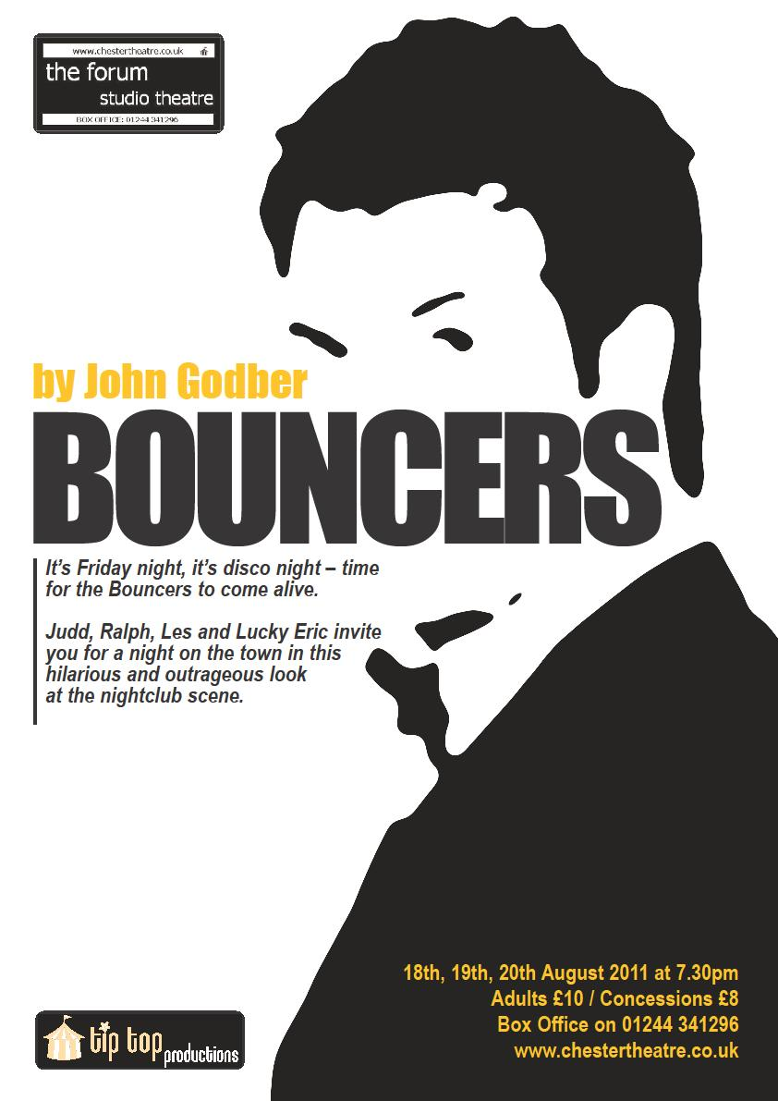
“Ladies and Gentlemen, we present Bouncers.
We welcome you to a vision
of the nineties’ urban night-life
To stag nights and hen-do’s
To drunken crying girls and gallons of booze”

Bursting with imagination and wit and presented by just four actors, Bouncers is an outrageous and hilarious parody of the disco scene. The four brutish bouncers of the title portray over twenty different characters as we are invited for a night out on the town. We see them as giggly girls and lads on the make preparing for the big night out as we follow their progress to the disco floor. There, we also meet an entire cross-section of disco-goers, including Hooray Henrys, pogoing punks and drunken slobs! The evening's events are set against the tatty glitzy glamour, flashing lights and pulsating beat of the nightclub scene.

Warning: This production contains Strong Language, Smoke, Flashing Lights and Strobe Lighting.

Also at the Forum Studio Theatre

The Houghton Weavers
Friday 26th August 7.30pm

Tip Top Productions presents

THE HISTORY BOYS

15th – 24th September

Sunny Rhyl
Returning prior to regional tour
1st October 7.30pm

SHOWTUNE
The music of Jerry Herman
10th – 19th November

01244 341296 WWW.CHESTERTHEATRE.CO.UK

Tip Top Productions aims to promote music, drama and theatre for all. Participation is open to anyone interested either on stage, backstage or front of house. To find out more about Tip Top, our future programme, or to be placed on our mailing list, please contact Peter Roberts at 20 Rhodfa Annwyl, Rhuddlan, LL18 2SQ or email: info@tiptoproductions.co.uk

www.tiptopproductions.co.uk

Tip Top Productions would like to thank the management and staff of The Stiwt for the help and support

